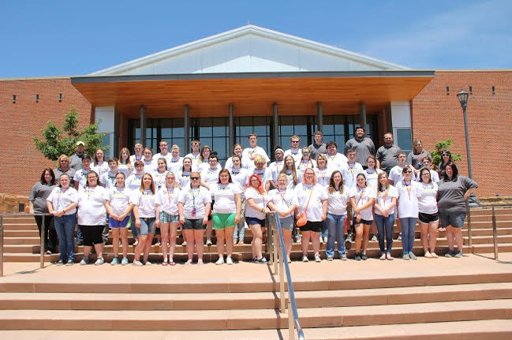

Upward Bound completes 50th summer at UVa-Wise
Upward Bound completed the 50th summer on The University of Virginia’s College at Wise campus as students finished academic classes to prepare them for the Virginia Standards of Learning courses and other electives they will have in the coming school term. The theme for this year was, “Gateway to The Future.”
English, Literature, Algebra II, Pre-calculus, Calculus, Math Analysis, Biology, Chemistry, U.S. History, Government, French and Spanish were among the classes offered in the program. This year, the program also offered afternoon project classes in Art, Music Ensemble, 3D Printing and Theatre and each project prepared a presentation to perform on Family Night.
Eleven Bridge students (students who graduated from high school in the spring and are enrolled in college this fall semester) were enrolled in classes for college credit. College classes available to Bridge students consisted of Communication, Psychology, Introduction to Art, Computer Literacy, English, History, Religion and Biology. The Bridge students also participated in a work-study program in offices on campus.
There were opportunities for students to take part in community service projects on campus as well as the MECC Haunted Forest. Jessica Ketron from MECC’s Talent search and Gain program visited the students to speak about budgeting and give information about MECC. Another Upward Bound program from Southwest Virginia Community College also paid a visit to the students as they all enjoyed a magic show together performed by Joseph Young.
The Upward Bound students also participated in several activities off campus. The students went to Barter Theatre and enjoyed the musical, “Mama Mia,” and received a behind the scenes tour of the studios in which the actors and actresses practice and get ready for performances. They also attended the East Kentucky Science Center and Planetarium where they viewed, “Oasis in Space” and a pop hits laser show. Students also visited the VA/KY District Fair and watched shows and rode the rides.
The summer session concluded with the annual Family Night celebration. The end of the summer trip was to Williamsburg VA, where students enjoyed a tour of Monticello, Jamestown, and got to participate in the Cry Witch Trials. They stayed at the Great Wolf Lodge and visited Virginia Beach and Busch Gardens.
Students who completed the summer program were: Tra Abbott, Kylie Barlow, Jasmine Bowen, Desirae Collins, Gabrielle Collins, Bailee Cox, Emily Elswick, Mason Elswick, Cassie Farmer, Caitlin France, Macey Funk, Brittany Gentry, Caitlin Harvey, Tiffany Hill, Isabella Horne, Anamarie Hylton, Brian Jackson, Jonathan Lawson, Jerryd Meade, Eboney Mooney, Beth Moore, Selena Moore, Isaac Mullins, Jennifer Mullins, Justin Mullins, Olivia Mullins, Marisca Rose, Hannah Russell, Liah Strouth, Maranda Strouth, James Turner and Derrick Yates.
Bridge Students included were: Chase Brock, Rebecca Freeman, Alexis Keesee, Olivia Keesee, Walker Lawson, Hayley McCarty, Nikki Mullins, Alexandria Pridemore, Vanessa Stallard, Savannah Yeary and Nicole Crouse.
Upward Bound of the University of Virginia’s College at Wise is a pre-college program serving low income and/or first-generation high school students from schools in Wise and Dickenson counties: Central, Eastside and Ridgeview.
The program serves 80 students with the grant renewal funded by the U.S Department of Education. This program has been at the college since 1966. The program activities are free to the students, who also receive a stipend for participation.
Students will participate in tutoring and classes each month and optional cultural and social activities. Students receive free tutoring, academic counseling, motivational sessions, test information and college prep. Upward Bound also pays for the PSAT, SAT, ACT, college applications, financial aid workshops and dual enrollment for junior and senior participants who qualify.
Interested students may check with their school guidance counselor or call the Upward Bound office at 276-328-0175 for eligibility requirements and application information. Students must be enrolled in college-bound track classes, including dual enrollment and foreign language, plan to enroll in college to receive at least an associate’s or baccalaureate degree and maintain at least a 2.5 GPA.
Information may also be found on the college web site at http://upwardbound.uvawise.edu/ or at https://www.facebook.com/upward.bound.10

